**Assessment Instructions**

**Instructions:** Write a program to convert to and from English and metric units of measurement. This program should be written with methods for each conversion.

1. If the Declaring Static Methods project has not yet been created in the Unit07



Assessments folder, please do so now.

2. A partially completed program

(MeasurementConverterV2.java) was provided

to help you get started. If you did not download it previously, do so now.

3. Read the comments in the program to guide you through the process.

4. Open the file and examine the source code. Start at the main method and complete each conversion, one at a time. Use the conversion factors from the MeasurementConverterV1 program.

5. Do not be overwhelmed by all of the comments, they are there for a reason.

They will guide you through every step of the process.

6. Use completed statements as models for the new statements that you write.

7. Add two more unit conversions of your choice that were not in the original program.

**Expected Output:** When the program runs correctly, the output will resemble the following screen shot and include your two new conversions.

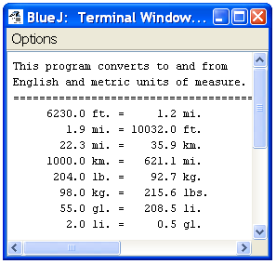

**Assessment:** Your assessment will be graded according to the following rubric.

|  |  |
| --- | --- |
| **Grading Rubric** | **Pts** |
| Comments include name, date, and purpose of program. | 1 |
| Methods documented with comments. | 1 |
| Method headers correctly written. | 4 |
| Individual static methods invoked from **main()** method. | 3 |
| All calculations correct. | 2 |
| Arguments and parameters correspond. | 1 |
| Output formatted with **printf()**. | 1 |
| No compiler or runtime errors. | 1 |
| Thoughtful PMR included. | 1 |

**Submission:** Submit the MeasurementConverterV2.java file as Defining New Static Methods: Part 1 for a grade.